
TASK 6 REPORT
DATABASE DESIGN AND IMPLEMENTATION
CEF440: PROGRAMMING AND MOBILE PROGRAMMING

REPUBLIC OF CAMEROON

PEACE-WORK-FATHERLAND
BUEA, SOUTH WEST REGION
UNIVERSITY OF BUEA

FACULTY OF ENGINEERING AND TECHNOLOGY
(FET)

By:
GROUP 4 MEMBERS

COURSE INSTRUCTOR:

Dr. Engr. NKEMENI VALERY

Name | Matricule
AKO JUNIOR NGOH | FE23A008
ETUMA ELKINGS BOSANGO | FE23A053
MOUKAM HAKO BELLAMY STEVE | FE23A096
NJIKANG BRIGHT NDODE NGONE | FE23A115
RINGNYU MBUNWE GIYOH LEMUEL | FE23A136
Table of Contents
Introduction 4
2. Tools, Languages and Technologies Used 5
2.1 Programming Languages 5
2.1.1 JavaScript (Node.js) 5
2.1.2 SQL (PostgreSQL Dialect) 5
2.2 Runtime and Framework 6
2.2.1 Node.js 6
2.2.2 Express.js (v5.2.1) 6
2.3 Database 7
2.3.1 PostgreSQL 7
2.3.2 Neon DB 7
2.3.3 pgcrypto Extension 7
2.4 npm Packages 8
2.5 Other Tools 8
3. Data Elements 9
3.1 Device Data 9
3.2 Network Metric Data 9
3.3 Location Data 10
3.4 Feedback Data 11
4. Conceptual Design 12
4.1 Entities 12
4.2 Relationships 12
4.3 Design Decisions 13
5. ER Diagram 15
5.1 Key for the Diagram 15
5.2 Referential Integrity 16
6. Database Implementation 17
6.1 Database Setup 17
6.2 Creating the subscriber_device Table 17
6.3 Creating the network_metric Table 17
6.4 Creating the location Table 18
6.5 Creating the feedback Table 18
6.6 Creating Indexes 19
7. Backend Implementation 20
7.1 Project Structure 20
7.2 Layers and Their Responsibilities 21
7.3 API Endpoints 22
7.4 Validation Middleware 22
8. Connecting the Database to the Backend 24
8.1 The Database Configuration File 24
8.2 The .env File 25
8.3 Server Startup Sequence 25
8.4 How a Request Flows Through the System 26
8.5 Service Layer SQL Example 27
Conclusion 29
References 30

Introduction
This report covers Task 6 of the CEF440 course project, which focuses on the database design and implementation for the SpeeDT QoE Mobile Network Monitoring Application developed by Group 4 at the University of Buea. After going through requirement gathering in Task 2, requirement analysis in Task 3, system modelling in Task 4, and the user interface implementation in Task 5, this task now deals with how data is actually stored, organised and accessed in the system.
SpeeDT is a crowdsensing application that collects mobile network quality data from ordinary smartphone users across Cameroon and uses that data to give both individual users and network operators useful insights about network performance. From the survey we conducted in Task 2, we found that about 94% of respondents experience network problems regularly, and the most affected areas include slow internet speed and poor signal strength. MTN was used by over 83% of the respondents in our sample. The application was designed to address this by collecting objective measurements like signal strength, download and upload speeds, and latency, as well as subjective ratings from users about their experience with the network.
For all of this to work properly, there needs to be a solid database layer that can store the collected data reliably, allow it to be queried efficiently, and connect all parts of the system together. This task covers the following:
- Identifying the data elements the system needs to store
- Designing the conceptual model and entity-relationship diagram
- Implementing the actual PostgreSQL database on a cloud platform called Neon DB
- Building the backend REST API using Node.js and Express
- Connecting the backend to the database so the mobile app can send and retrieve data

2. Tools, Languages and Technologies Used
Before getting into the design, it is important to explain what tools and technologies we used for this task, why we chose them, and how exactly each one was used in the implementation.
Tool and Technology | Purpose / Description
Node.js | Runtime Environment
Express.js | HTTP Framework
PostgreSQL | Relational Database
Neon DB | Cloud DB Host
pg (v8.21) | Node.js DB Driver
dotenv | Config / Secrets
cors | CORS Middleware
nodemon | Dev Auto-restart

2.1 Programming Languages

2.1.1 JavaScript (Node.js)
The entire backend is written in JavaScript running on the Node.js runtime. We chose JavaScript because the frontend of SpeeDT is already built with React Native, which also uses JavaScript. This meant the team did not have to switch between languages when working on different parts of the system. JavaScript on Node.js is also well suited for building APIs because it handles many connections at the same time without blocking, which is important when hundreds of devices are trying to send data at once.
Every file in the backend source folder uses JavaScript. The service files, controllers, route files, middleware and the database configuration file are all written using CommonJS module syntax.

2.1.2 SQL (PostgreSQL Dialect)
SQL is used to define the structure of the database and to run queries for inserting and reading data. PostgreSQL has its own dialect of SQL which adds useful features on top of the standard. The one we used the most is gen_random_uuid() which comes from the pgcrypto extension and generates a random UUID. We also used TIMESTAMPTZ for timestamp columns because it stores time with timezone information, which avoids problems when comparing times from different locations.
All SQL statements in the backend are written as template strings inside the service files and are sent to the database through parameterised queries, which means the values are passed separately from the SQL text. This prevents SQL injection attacks where someone could try to manipulate the query by putting SQL code into a request field.
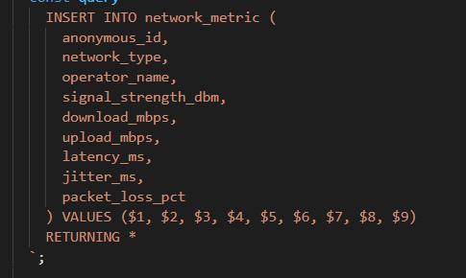

The $1, $2... placeholders are filled by the values array separately, so a user cannot inject SQL through request data.

2.2 Runtime and Framework

2.2.1 Node.js
Node.js is the environment that runs the backend JavaScript code. It is not a framework but a runtime, which means it is the thing that actually executes the code. We used version 18 of Node.js. The entry point of the backend, which is the server.js file, runs directly in Node.js. It reads environment variables through process.env and starts the HTTP server on the configured port.

2.2.2 Express.js (v5.2.1)
Express is the HTTP framework we used to handle incoming requests from the mobile app and send back responses. It was initialised in the app.js file. Express was used to register two types of global middleware first, cors() which allows the mobile app to call the API from a different network origin, and express.json() which tells Express to automatically parse incoming JSON request bodies so the controllers can read them as JavaScript objects. Express was also used to mount all the route groups under their respective URL prefixes.

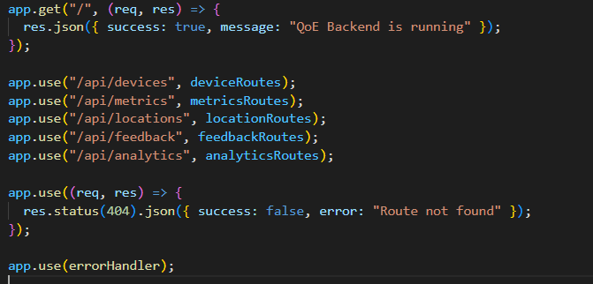

2.3 Database

2.3.1 PostgreSQL
PostgreSQL is the relational database management system we used to store all data for SpeeDT. We chose it because it is open source, reliable, and supports features like UUID primary keys, timezone-aware timestamps, and the pgcrypto extension. It is also fully ACID compliant which means it guarantees that data is not lost or corrupted even if something goes wrong during a transaction. We created four tables in PostgreSQL: subscriber_device, network_metric, location, and feedback.

2.3.2 Neon DB
Rather than running PostgreSQL on a local server, we used Neon DB which is a managed cloud platform that hosts PostgreSQL without requiring us to manage any infrastructure. Neon DB was a practical choice for this project because it has a free tier, it scales automatically, and it provides a connection string that works with the standard pg Node.js driver without any extra configuration. The connection to Neon DB uses SSL encryption which means data sent between the backend server and the database is always encrypted in transit.

2.3.3 pgcrypto Extension
pgcrypto is a PostgreSQL extension that provides cryptographic functions. We enabled it in our database because it includes the gen_random_uuid() function, which is used as the default value for the anonymous_id column in the subscriber_device table. This means every time a new device registers, the database automatically generates a cryptographically secure UUID without the application needing to generate one itself.

CREATE EXTENSION IF NOT EXISTS "pgcrypto";

CREATE TABLE subscriber_device (
anonymous_id UUID PRIMARY KEY DEFAULT gen_random_uuid(),
...
);

2.4 npm Packages
The following packages were installed using npm and listed in the package.json file:

Package | Version | Purpose and How It Was Used
express | 5.2.1 | The HTTP framework. Used to create the app, register middleware, and define all API routes.
pg | 8.21.0 | The PostgreSQL driver for Node.js. Used to create a connection pool and run all SQL queries against the database.
dotenv | 17.4.2 | Reads the .env file and makes DATABASE_URL and PORT available through process.env at startup.
cors | 2.8.6 | Adds the Access-Control-Allow-Origin header to all responses so the mobile app can call the API without being blocked.
nodemon | 3.1.14 | Development tool that watches backend files and automatically restarts the server when a file changes.

2.5 Other Tools
The following additional tools were used during this task:
- draw.io: Used to create the conceptual design and entity-relationship diagrams. The .drawio files are provided alongside this report.
- VS Code: The code editor used to write all backend source files.
- Postman / REST Client: Used to test the API endpoints manually during development. The test.rest file in the project uses the REST Client extension in VS Code.
- Git and GitHub: Version control for the project. The source code was hosted under the SpeeDT-main repository.
- Neon DB Console: The web dashboard provided by Neon DB where we created the PostgreSQL database, ran SQL statements to set up the tables, and checked connection status

3. Data Elements
Data elements are the individual pieces of information that the system needs to store in the database. We identified them by going through the functional requirements in the SRS document and then checking what each backend service actually reads and writes. The SpeeDT system has four categories of data, each corresponding to one of the four database tables.

3.1 Device Data
Every time someone installs the SpeeDT application on their phone and opens it for the first time, the app registers itself as a subscriber device. This is the most important entity in the entire database because every other piece of data, every metric, every location reading, every feedback rating, belongs to a device. The following fields make up the device data:

Field | Data Type | Description
anonymous_id | UUID | Auto-generated unique identifier. Used instead of a phone number or IMEI to protect user privacy.
device_model | TEXT | The hardware model of the device, for example Samsung Galaxy S22.
os | TEXT | The operating system and version, for example Android 15 or iOS 17.
app_version | TEXT | The version of SpeeDT installed on the device.
consent_given | BOOLEAN | Whether the user agreed to data collection on the consent screen. Defaults to false.
data_collection_enabled | BOOLEAN | Whether background data collection is currently active. The user can toggle this from settings.
wifi_only_uploads | BOOLEAN | If true, the app only sends data to the backend over Wi-Fi to save mobile data costs.
notifications_enabled | BOOLEAN | Whether push notifications for network quality alerts are enabled.
registered_at | TIMESTAMPTZ | The exact date and time the device was registered. Stored with timezone.

3.2 Network Metric Data
The background service of the SpeeDT app collects one metric reading approximately every 60 seconds while the app is running. Each reading is one snapshot of what the network looks like at that moment. Over time these readings build up into a history that can be used to show trends and identify problem areas.

Field | Data Type | Description
metric_id | SERIAL | Auto-incremented integer that uniquely identifies each metric reading.
anonymous_id | UUID | Foreign key linking this metric to the device that recorded it.
network_type | TEXT | The type of network connection at the time, such as 2G, 3G, 4G LTE, 5G, or WiFi.
operator_name | TEXT | The mobile network operator detected, for example MTN, Orange, or CAMTEL.
signal_strength_dbm | INTEGER | Signal strength in dBm. Negative values where closer to zero means stronger signal.
download_mbps | NUMERIC(8,2) | Measured download speed in megabits per second with two decimal places.
upload_mbps | NUMERIC(8,2) | Measured upload speed in megabits per second.
latency_ms | NUMERIC(8,2) | Round trip ping time in milliseconds. Lower values mean less delay.
jitter_ms | NUMERIC(8,2) | Variability in the latency. High jitter means the connection is unstable even if average latency looks acceptable.
packet_loss_pct | NUMERIC(5,2) | Percentage of data packets lost. Values above about 2% cause noticeable problems on calls and streaming.
recorded_at | TIMESTAMPTZ | Timestamp of when the measurement was taken.

3.3 Location Data
Location records link network readings to geographic coordinates. This enables the coverage mapping feature where it is possible to see on a map which areas have good or poor network quality. According to NFR-02 in the SRS, the user must give explicit permission before location data is collected, and the location is generalised to district level before being stored to protect privacy. Location is kept in a separate table from the metrics so that location tracking can be enabled or disabled independently without affecting metric collection.

Field | Data Type | Description
location_id | SERIAL | Auto-incremented primary key.
anonymous_id | UUID | Foreign key linking this location to the device.
latitude | DOUBLE PRECISION | Geographic latitude coordinate.
longitude | DOUBLE PRECISION | Geographic longitude coordinate.
location_name | TEXT | Human readable area name such as Buea Highway or Molyko.
recorded_at | TIMESTAMPTZ | Timestamp of the location reading.

3.4 Feedback Data
When the application detects that network quality has dropped, or at regular intervals configured by the user, it prompts the user to rate their experience. These subjective ratings complement the objective metric data. A user might see good download speeds on paper but still feel the network is slow, and the feedback data captures that perception gap.

Field | Data Type | Description
feedback_id | SERIAL | Auto-incremented primary key.
anonymous_id | UUID | Foreign key linking feedback to the submitting device.
metric_id | INTEGER | Optional foreign key linking this feedback to a specific metric reading. Can be null.
overall_rating | INTEGER | Overall satisfaction from 1 to 5 stars.
speed_rating | INTEGER | Perceived speed rating from 1 to 5.
delay_rating | INTEGER | Perceived latency or delay rating from 1 to 5.
reliability_rating | INTEGER | Perceived connection stability rating from 1 to 5.
comment | TEXT | Optional free-text comment the user can add.
submitted_at | TIMESTAMPTZ | Timestamp of when the feedback was submitted.

4. Conceptual Design
The conceptual design is the first step in modelling the database. At this stage we are not yet concerned with specific data types or SQL syntax. The goal is simply to identify the main things the system needs to store data about and to understand how those things relate to each other. This is usually expressed using an entity relationship diagram drawn in Chen notation, where entities are shown as ellipses, relationships between entities are shown as diamonds, and the attributes of each entity are shown as smaller ellipses attached to the main entity.

4.1 Entities
We identified four main entities in the SpeeDT system. An entity represents a distinct type of object about which the system stores data:
SUBSCRIBER_DEVICE
This entity represents a unique installation of the SpeeDT app on a smartphone. Every other entity in the database is linked back to this one. It stores the device metadata and the user consent and preference settings.
NETWORK_METRIC
This entity represents a single timestamped reading of network conditions. Each reading captures the signal strength, speeds, latency, jitter, and packet loss at one moment in time. A device can produce many of these readings.
LOCATION
This entity represents a GPS reading recorded by the device. It stores the coordinates and a place name so that network readings can be mapped to geographic areas. A device can have many location records.
FEEDBACK
This entity represents a quality of experience rating submitted by the user. It contains star ratings across four dimensions and an optional comment. A device can submit many feedback entries.

4.2 Relationships

From Entity | Relationship | To Entity | Cardinality
SUBSCRIBER_DEVICE | generates | NETWORK_METRIC | 1 to N
SUBSCRIBER_DEVICE | records | LOCATION | 1 to N
SUBSCRIBER_DEVICE | submits | FEEDBACK | 1 to N
NETWORK_METRIC | linked to | FEEDBACK | 1 to 0..1 (optional)

One device generates many metric readings over its lifetime. One device records many location entries as it moves around. One device can submit many feedback ratings. A metric reading may be linked to a feedback entry if the feedback was triggered by that specific measurement, but this link is not required which is why the cardinality shows 0..1 on the feedback side.

4.3 Design Decisions
Privacy-first identifiers: Rather than storing a phone number or IMEI which would identify the user personally, the system generates a UUID when the device registers. This UUID is what connects all the tables together. NFR-07 in the SRS document specifically prohibits storing raw personal identifiers.

Separate location table: We kept location data in its own table instead of adding latitude and longitude columns to the metric table. This makes it possible to enable or disable location tracking independently based on user consent, without affecting how metrics are collected.

Optional link between metric and feedback: The metric_id column in the feedback table can be null. This is intentional because the app allows users to submit a general rating at any time, not just when a specific metric event was detected. If there is a specific triggering metric, the link is stored. If not, the feedback is still saved without it.

Append-only measurement tables: Metric and location records are never updated after they are inserted. Each reading is always a new row with its own timestamp. This preserves the full history of measurements and prevents any accidental loss of historical data through in-place updates.

The diagram below shows the conceptual model using Chen ER notation. Entities are shown as blue ellipses, relationship diamonds are in yellow, and attribute ellipses are attached to each entity with dashed lines.

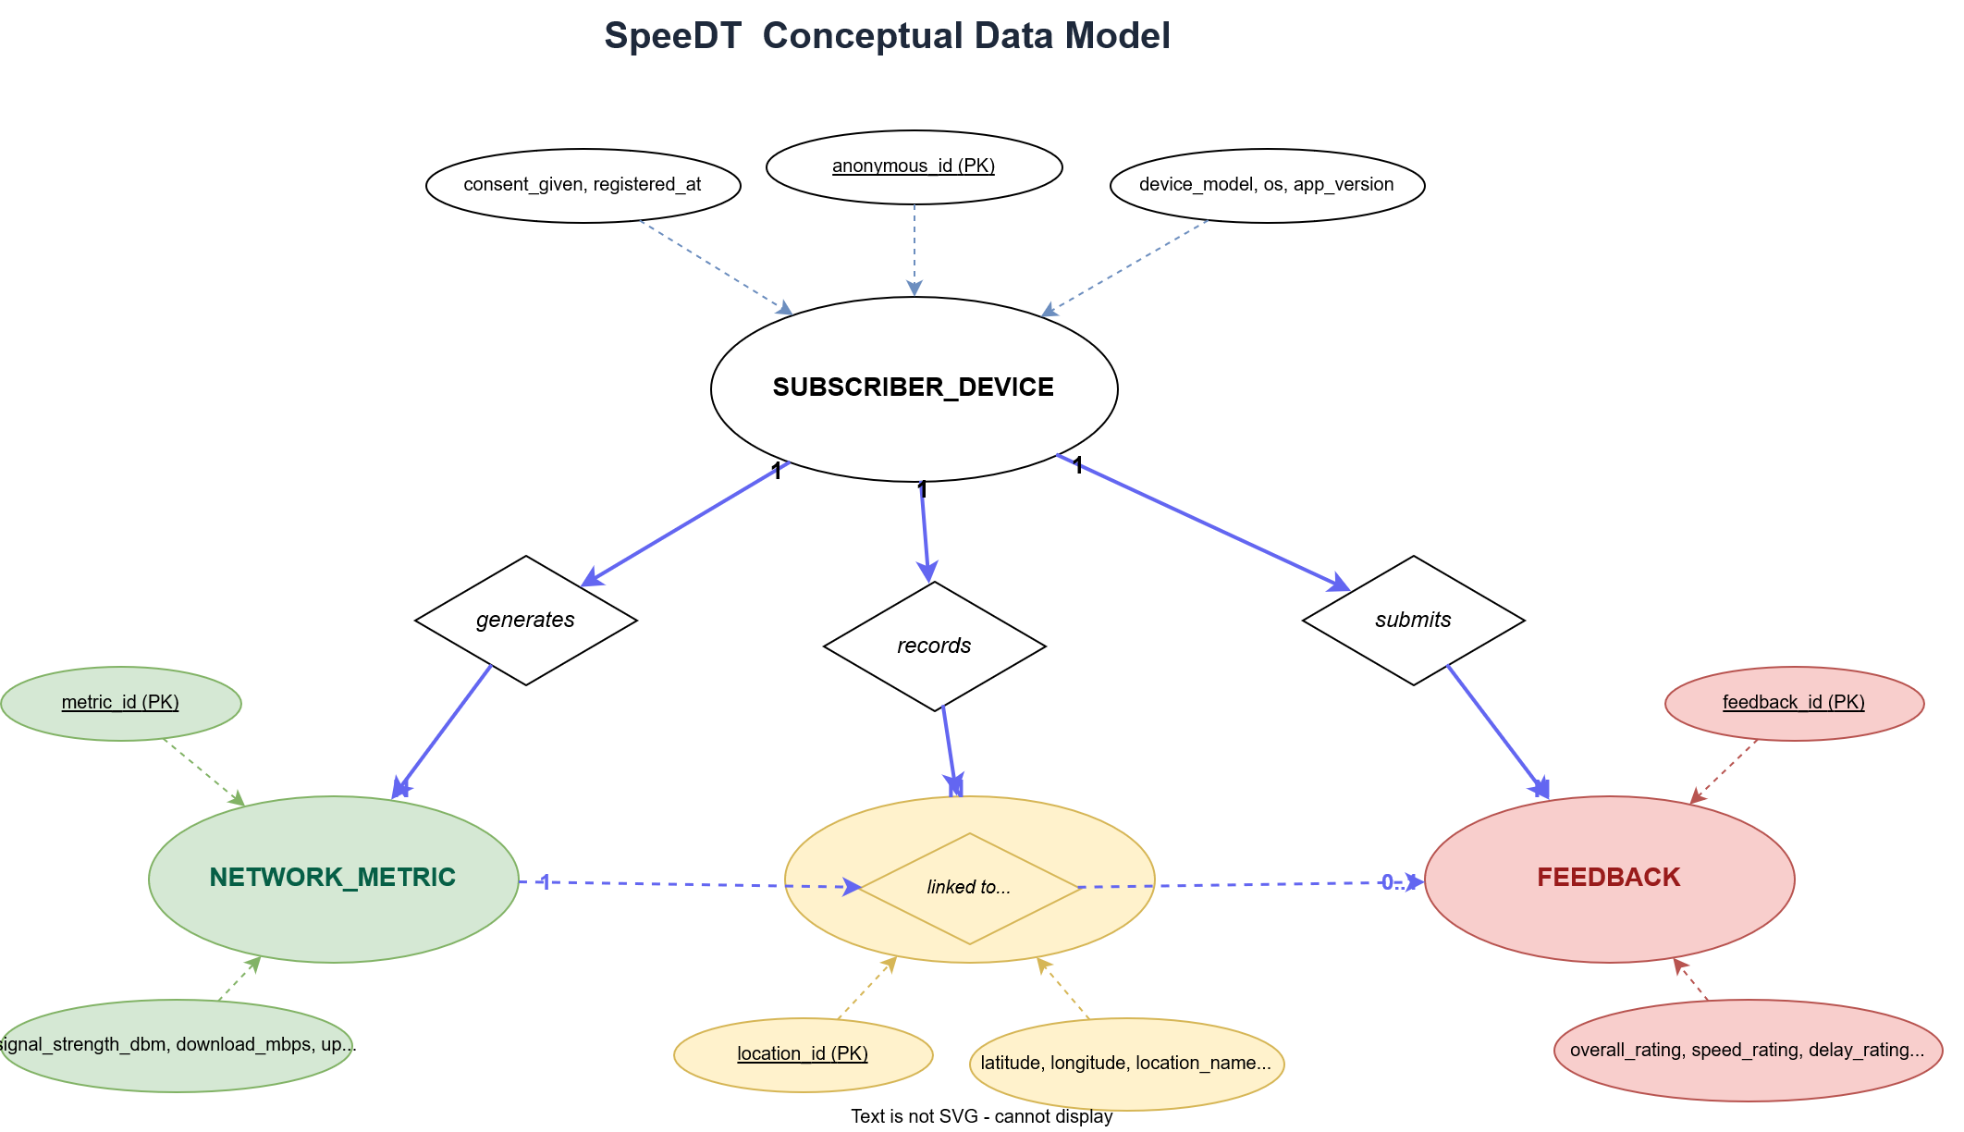
Figure 1 - Conceptual Data Model (Chen ER Notation)

5. ER Diagram
The entity-relationship diagram below shows the four database tables with their columns, data types, primary keys and foreign keys, and the relationships between the tables. Unlike the conceptual design which uses Chen notation, this diagram uses table notation which is closer to the actual implementation in the database. Each table is shown as a box with its column names and types, and the relationships between tables are shown as arrows connecting them.

5.1 Key for the Diagram
- PK stands for Primary Key, which is the unique identifier for each row in a table.
- FK stands for Foreign Key, which is a column that references the primary key of another table.
- FK? stands for an optional Foreign Key, meaning the column can be null.
- 1:N on a relationship line means one record in the first table can link to many records in the second table.
- 1:0..1 means one record in the first table can link to zero or one records in the second table. This is used for the optional link between network_metric and feedback.
- Solid arrows show mandatory relationships. Dashed arrows show optional relationships.

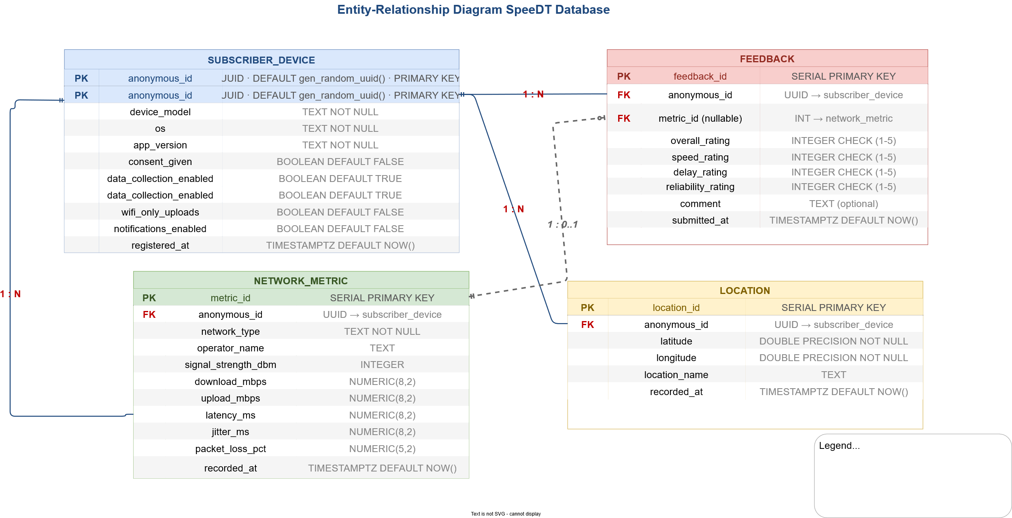
Figure 2 - Entity-Relationship Diagram

5.2 Referential Integrity
The foreign key relationships in the diagram enforce referential integrity, which means the database will not allow a metric, location, or feedback record to reference a device that does not exist. We also specified what happens when a parent record is deleted:

Parent Table | ON DELETE Rule | Effect
subscriber_device | CASCADE | Deleting a device deletes all its metrics, locations, and feedback automatically.
network_metric (metric_id) | SET NULL | If a metric is deleted, any feedback that referenced it keeps its other data but the metric_id is set to null.

6. Database Implementation
This section covers the actual SQL statements used to create the database structure. We created the database on Neon DB using their web console, then ran these SQL statements to set up the tables and indexes.

6.1 Database Setup
The first thing we needed to do was enable the pgcrypto extension so that the gen_random_uuid() function would be available. We ran the following statement in the Neon DB SQL editor:
CREATE EXTENSION IF NOT EXISTS "pgcrypto";
The IF NOT EXISTS part means this statement will not throw an error if the extension is already enabled. This is important because the backend also runs this statement every time it starts up to make sure the extension is there.

6.2 Creating the subscriber_device Table
This table was created first because all the other tables reference it through foreign keys. If we tried to create the other tables first, the database would give an error because the table they are trying to reference does not exist yet.
CREATE TABLE subscriber_device (
anonymous_id UUID PRIMARY KEY DEFAULT gen_random_uuid(),
device_model TEXT NOT NULL,
os TEXT NOT NULL,
app_version TEXT NOT NULL,
consent_given BOOLEAN DEFAULT FALSE,
data_collection_enabled BOOLEAN DEFAULT TRUE,
wifi_only_uploads BOOLEAN DEFAULT FALSE,
notifications_enabled BOOLEAN DEFAULT FALSE,
registered_at TIMESTAMPTZ DEFAULT NOW()
);
The anonymous_id column is the primary key and its default value is gen_random_uuid() which means PostgreSQL generates a new UUID automatically each time a device registers. The NOT NULL constraint on device_model, os, and app_version means the registration will be rejected if any of these fields are missing. The boolean columns have safe defaults, for example consent_given starts as false so data collection is always off until the user explicitly consents.

6.3 Creating the network_metric Table
CREATE TABLE network_metric (
metric_id SERIAL PRIMARY KEY,
anonymous_id UUID NOT NULL
REFERENCES subscriber_device(anonymous_id)
ON DELETE CASCADE,
network_type TEXT NOT NULL,
operator_name TEXT,
signal_strength_dbm INTEGER,
download_mbps NUMERIC(8, 2),
upload_mbps NUMERIC(8, 2),
latency_ms NUMERIC(8, 2),
jitter_ms NUMERIC(8, 2),
packet_loss_pct NUMERIC(5, 2),
recorded_at TIMESTAMPTZ DEFAULT NOW()
);
We used SERIAL for the metric_id which is a PostgreSQL shorthand that creates an auto-incrementing integer. The REFERENCES keyword creates the foreign key constraint which will reject any insert where the anonymous_id does not exist in the subscriber_device table. Most of the measurement columns are nullable because some measurements cannot be read on all platforms. For example, raw signal strength in dBm is not available on iOS devices, so if that field is null it just means the app could not read that value on that device.

6.4 Creating the location Table
CREATE TABLE location (
location_id SERIAL PRIMARY KEY,
anonymous_id UUID NOT NULL
REFERENCES subscriber_device(anonymous_id)
ON DELETE CASCADE,
latitude DOUBLE PRECISION NOT NULL,
longitude DOUBLE PRECISION NOT NULL,
location_name TEXT,
recorded_at TIMESTAMPTZ DEFAULT NOW()
);
We used DOUBLE PRECISION for latitude and longitude because geographic coordinates need many decimal places to be accurate. A standard float would lose precision at the level of detail needed for mapping.

6.5 Creating the feedback Table
CREATE TABLE feedback (
feedback_id SERIAL PRIMARY KEY,
anonymous_id UUID NOT NULL
REFERENCES subscriber_device(anonymous_id)
ON DELETE CASCADE,
metric_id INTEGER
REFERENCES network_metric(metric_id)
ON DELETE SET NULL,
overall_rating INTEGER CHECK (overall_rating BETWEEN 1 AND 5),
speed_rating INTEGER CHECK (speed_rating BETWEEN 1 AND 5),
delay_rating INTEGER CHECK (delay_rating BETWEEN 1 AND 5),
reliability_rating INTEGER CHECK (reliability_rating BETWEEN 1 AND 5),
comment TEXT,
submitted_at TIMESTAMPTZ DEFAULT NOW()
);
The metric_id column in this table has no NOT NULL constraint, which means it is optional. The CHECK constraints on the rating columns make sure only values between 1 and 5 are accepted. This is a second layer of protection after the validation middleware in the backend already checks this before the query even runs.

6.6 Creating Indexes
Indexes speed up queries by allowing the database to find records without scanning every row in the table. The most common queries in SpeeDT look up records by anonymous_id, and metric queries are usually sorted by time with the most recent first. We created indexes to support those patterns:

CREATE INDEX idx_metric_anonymous_id ON network_metric(anonymous_id);
CREATE INDEX idx_metric_recorded_at ON network_metric(recorded_at DESC);
CREATE INDEX idx_location_anonymous_id ON location(anonymous_id);
CREATE INDEX idx_feedback_anonymous_id ON feedback(anonymous_id);

7. Backend Implementation
The backend is a REST API server that receives HTTP requests from the SpeeDT mobile app, validates the data in those requests, runs the appropriate database operation, and sends back a JSON response. It was built using Node.js and Express and follows a layered architecture where each layer has one specific responsibility.

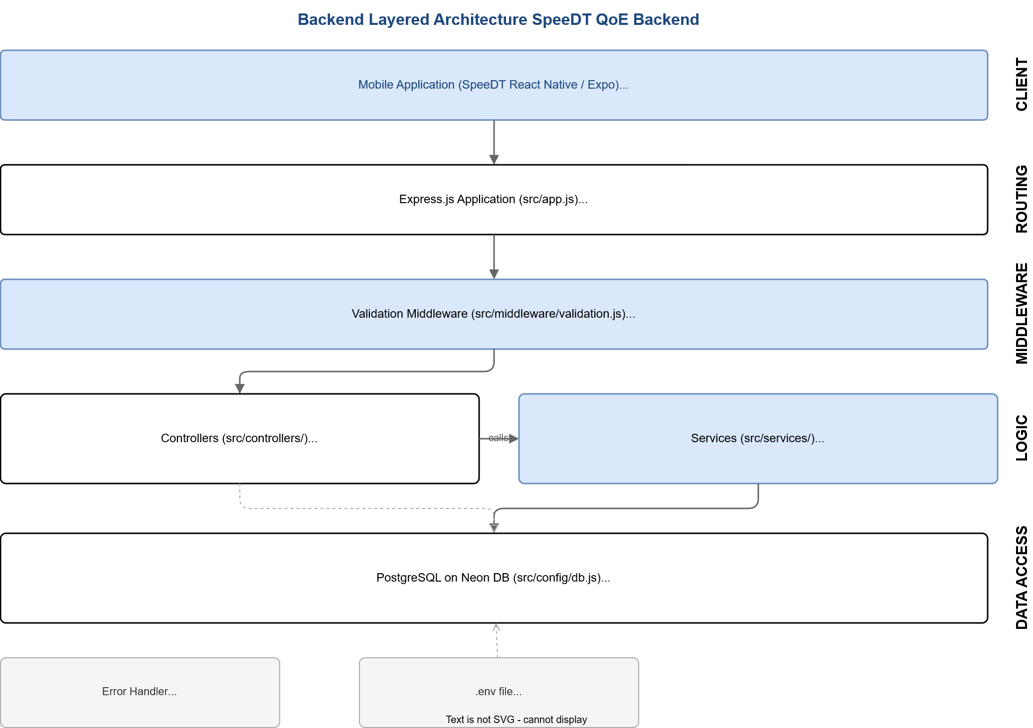
Figure 3 - Backend Layered Architecture

7.1 Project Structure
The backend source code is organised as follows:
QoE_Backend/
├── server.js (entry point)
├── package.json (npm dependencies)
├── .env (environment variables, not in git)
└── src/
├── app.js (Express setup)
├── config/
│ └── db.js (database connection pool)
├── routes/
│ ├── device.routes.js
│ ├── metrics.routes.js
│ ├── location.routes.js
│ ├── feedback.routes.js
│ └── analytics.routes.js
├── middleware/
│ ├── validation.js
│ └── errorHandler.js
├── controllers/
│ ├── device.controller.js
│ ├── metrics.controller.js
│ ├── location.controller.js
│ ├── feedback.controller.js
│ └── analytics.controller.js
└── services/
├── device.service.js
├── metrics.service.js
├── location.service.js
├── feedback.service.js
└── analytics.service.js

7.2 Layers and Their Responsibilities

Layer | Files | What It Does
Entry Point | server.js | Initialises the database connection then starts the HTTP listener. Exits immediately if the database connection fails.
Application | src/app.js | Creates the Express app, registers CORS and JSON middleware, mounts all route groups.
Routes | src/routes/ | Maps HTTP methods and URL paths to controller functions, with the validation middleware inserted in between.
Validation Middleware | src/middleware/validation.js | Checks that required fields are present and that UUID values are correctly formatted. Returns HTTP 400 for invalid requests.
Controllers | src/controllers/ | Handles the HTTP side of things. Reads from req, calls the service, and sends the JSON response via res.
Services | src/services/ | The only layer that touches the database. Contains all the SQL queries and calls pool.query() to run them.
Config | src/config/db.js | Creates and exports the PostgreSQL connection pool. Runs initDatabase() to enable the pgcrypto extension on startup.
Error Handler | src/middleware/errorHandler.js | Catches any error from any layer and sends a consistent JSON error response to the client.

7.3 API Endpoints
The following ten REST endpoints are available in the backend:

Method | Endpoint | Description
POST | /api/devices | Register a new device. The database generates an anonymous_id UUID and returns it to the app.
GET | /api/devices/:deviceId | Retrieve a registered device by its UUID. Returns 404 if the device is not found.
POST | /api/metrics | Ingest a new network metric reading from a device.
GET | /api/metrics/latest/:deviceId | Get the most recent metric reading for a specific device.
POST | /api/locations | Record a new GPS location entry for a device.
GET | /api/locations/history/:deviceId | Get the full location history for a device, ordered most recent first.
POST | /api/feedback | Submit a QoE feedback rating with optional metric link and comment.
GET | /api/analytics/average-speed/:deviceId | Calculate the average download and upload speeds across all metrics for a device.
GET | /api/analytics/average-qoe/:deviceId | Calculate the average values for all four rating dimensions in the feedback table for a device.
GET | /api/analytics/latest-metric/:deviceId | Get the latest metric for a device through the analytics route.

7.4 Validation Middleware
Before any controller function runs, the validation middleware checks the incoming request. It does three things:

Required field check:
It checks that all mandatory fields are present in the request body. If any required field is missing, it creates an error with status 400 and passes it to the error handler, which returns a JSON response like this:
{ "success": false, "error": "Missing required fields: anonymous_id, network_type" }
UUID sanitization:
Some API testing tools wrap placeholder values in angle brackets, for example <replace-with-device-id>. The sanitizer strips those characters so they do not cause a false validation failure.

UUID format validation:
It checks that the anonymous_id matches the RFC 4122 UUID format using a regular expression. This is important because the anonymous_id column in the database has type UUID, so if a malformed value got through it would cause a database error rather than a clean 400 response.

const isValidUUID = (value) => {
const uuidRegex = /^[0-9a-f]{8}-[0-9a-f]{4}-[1-5][0-9a-f]{3}-[89ab][0-9a-f]{3}-[0-9a-f]{12}$/i;
return typeof value === 'string' && uuidRegex.test(value.trim());
};

8. Connecting the Database to the Backend
This section explains how the Node.js backend actually connects to the PostgreSQL database on Neon DB, and what happens step by step when the mobile app sends a request.
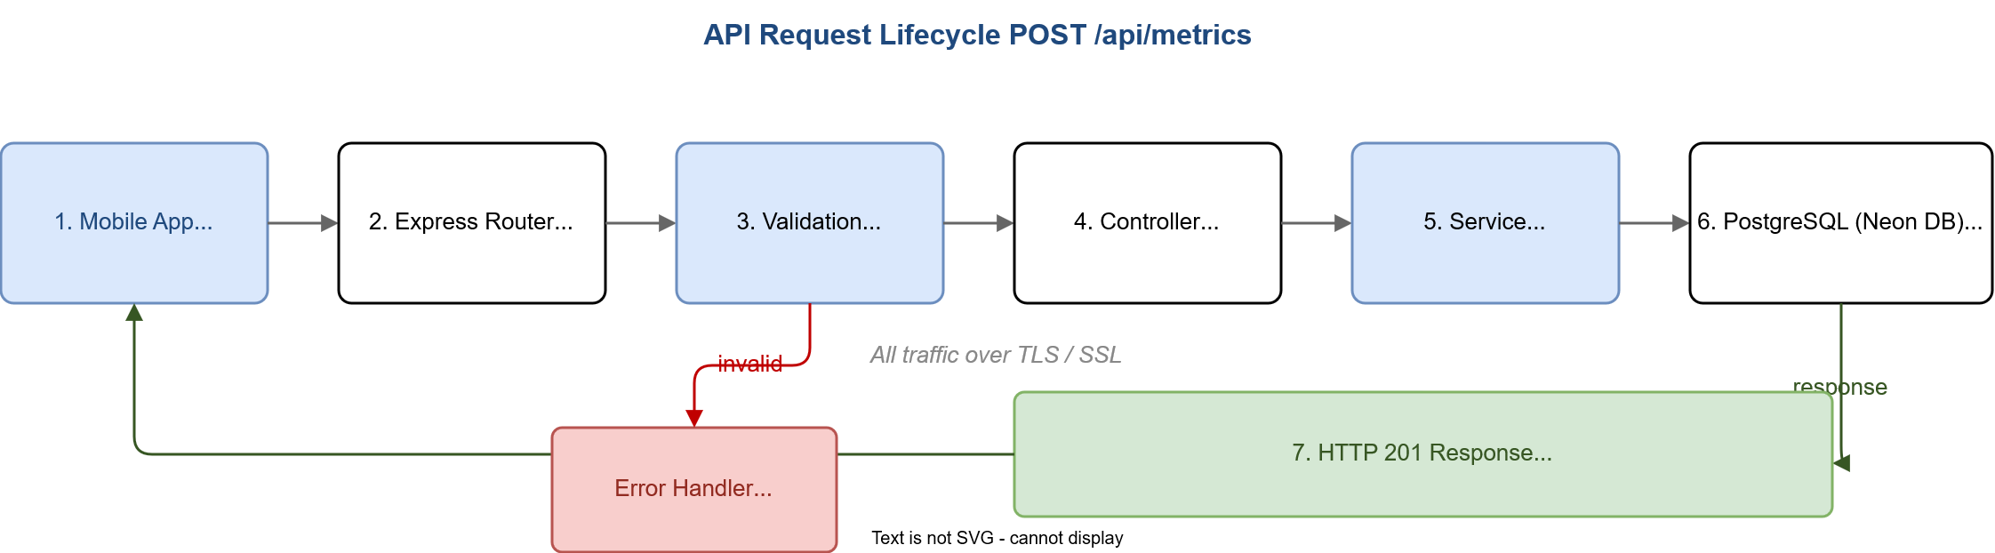
Figure 4 - API Request Lifecycle (POST /api/metrics)

8.1 The Database Configuration File
The connection between the backend and the database is set up in src/config/db.js. This file uses the Pool class from the pg library to create a pool of reusable database connections. Using a pool is important because opening a new connection to the database for every single API request would be too slow. With a pool, connections are kept open and reused, and the pool manages lending them out to service functions that need to run a query.
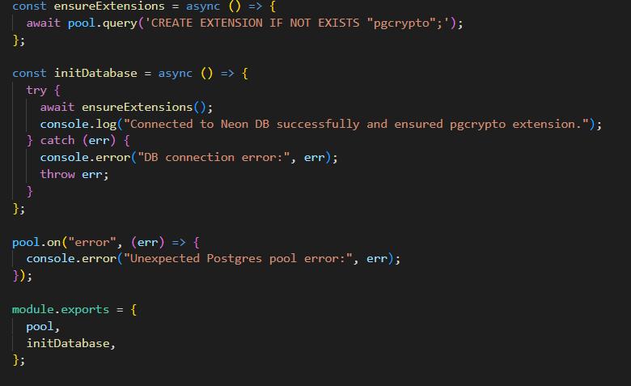
// src/config/db.js
const { Pool } = require('pg');
require('dotenv').config();

const pool = new Pool({
connectionString: process.env.DATABASE_URL,
ssl: { rejectUnauthorized: false },
});

const initDatabase = async () => {
try {
await pool.query('CREATE EXTENSION IF NOT EXISTS "pgcrypto";');
console.log('Connected to Neon DB successfully.');
} catch (err) {
console.error('DB connection error:', err);
throw err;
}
};

module.exports = { pool, initDatabase };
The ssl: { rejectUnauthorized: false } setting tells the pg library to accept the SSL certificate from Neon DB even without a local certificate authority. This is required because Neon DB enforces SSL on all connections. The DATABASE_URL comes from the .env file which is never committed to the repository.

8.2 The .env File
All sensitive configuration is stored in a .env file that is listed in .gitignore so it is never uploaded to GitHub. The dotenv package reads this file at startup and makes the values available through process.env.

8.3 Server Startup Sequence
The server.js entry point follows a deliberate order when starting up. It first loads the environment variables, then builds the Express application, then tries to connect to the database. Only if the database connection succeeds does it start listening for HTTP requests. If the database connection fails, the process exits immediately with an error code. This prevents the server from accepting requests it cannot actually serve.
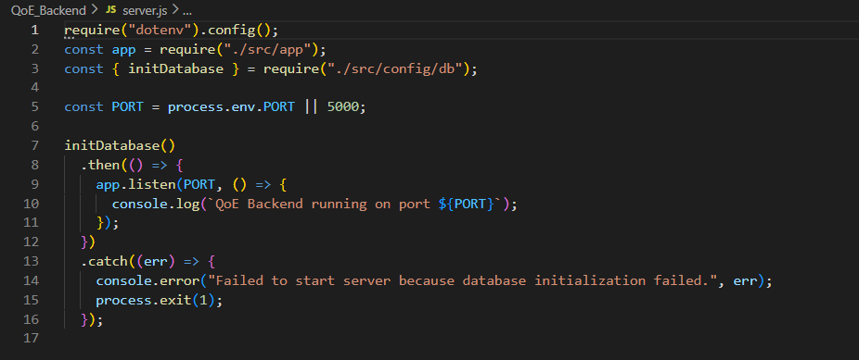

8.4 How a Request Flows Through the System
The diagram above shows the full lifecycle of a request. Below is a step by step explanation using the POST /api/metrics endpoint as an example:

Step 1: Mobile App sends request: The SpeeDT app running on the user's phone sends an HTTP POST request to /api/metrics with a JSON body containing the network measurement data.

Step 2: Express Router matches the route: Express receives the request and looks at the URL. It matches /api/metrics and passes the request to the metrics.routes.js handler, which specifies that the request should go through validateMetricIngestion middleware before reaching the controller.

Step 3: Validation Middleware runs: The middleware checks that anonymous_id and network_type are present, sanitizes the UUID, and validates its format. If anything is wrong, it passes an error to the error handler which sends back HTTP 400 and stops. If everything is fine, it calls next() to pass the request to the controller.

Step 4: Controller receives the validated request: The ingestMetric function in metrics.controller.js takes the validated request body and calls metricsService.ingestMetric(req.body). The controller itself does not write any SQL.

Step 5: Service runs the SQL query: metrics.service.js builds a parameterised INSERT statement and calls pool.query(query, values). The pg library borrows a connection from the pool, sends the query to Neon DB over TLS, waits for the result, and returns the connection to the pool.

Step 6: PostgreSQL executes the query: On the Neon DB server, PostgreSQL runs the INSERT, validates all constraints, writes the row to the network_metric table, generates the recorded_at timestamp using DEFAULT NOW(), and returns the inserted row through RETURNING *.

Step 7: Response is sent back: The service returns the inserted row to the controller. The controller calls res.status(201).json({ success: true, data: metric }). Express serialises this to JSON and sends the HTTP response back to the mobile app, which now has the confirmed metric_id and recorded_at timestamp.

8.5 Service Layer SQL Example
Every service file imports the shared pool object and uses it to run queries. Below is the complete metrics.service.js to show how the pattern works:
const { pool } = require('../config/db');

const ingestMetric = async ({
anonymous_id, network_type, operator_name,
signal_strength_dbm, download_mbps, upload_mbps,
latency_ms, jitter_ms, packet_loss_pct,
}) => {
const query = `
INSERT INTO network_metric (
anonymous_id, network_type, operator_name,
signal_strength_dbm, download_mbps, upload_mbps,
latency_ms, jitter_ms, packet_loss_pct
) VALUES ($1, $2, $3, $4, $5, $6, $7, $8, $9)
RETURNING *
`;
const values = [
anonymous_id, network_type, operator_name,
signal_strength_dbm, download_mbps, upload_mbps,
latency_ms, jitter_ms, packet_loss_pct,
];
const result = await pool.query(query, values);
return result.rows[0];
};

const getLatestMetricByDevice = async (anonymous_id) => {
const result = await pool.query(
`SELECT * FROM network_metric
WHERE anonymous_id = $1
ORDER BY recorded_at DESC LIMIT 1`,
[anonymous_id]
);
return result.rows[0];
};

module.exports = { ingestMetric, getLatestMetricByDevice };
The RETURNING * clause at the end of the INSERT statement tells PostgreSQL to send back the full inserted row. This gives the backend the metric_id and recorded_at values which were generated by the database and not known until after the insert, so they can be included in the HTTP response without needing a separate SELECT query.

Conclusion
This task covered the complete database design and implementation for the SpeeDT QoE Mobile Network Monitoring Application. We started by identifying the data elements the system needs to store and organised them into four entities: subscriber device, network metric, location, and feedback. We then created a conceptual model using Chen ER notation to show the entities and their relationships before implementing the actual database schema in PostgreSQL.
The four-table schema supports all the functional requirements listed in the SRS document. The use of UUIDs as anonymous identifiers addresses the privacy requirements in NFR-07. The CHECK constraints on rating columns and the NOT NULL constraints on required fields help maintain data integrity at the database level, providing a second layer of protection after the backend validation middleware.
The layered backend architecture with routes, middleware, controllers, services, and a shared database config means that each part of the code has one job and does not need to know about the other parts. The service layer is the only place where SQL is written, which means if the database schema ever changes, only the service files need to be updated.
With the database and backend now in place, the SpeeDT system has a working data layer that can receive metric readings from devices across Cameroon, store them reliably in the cloud, and serve them back for display on the dashboard and for analysis by network operators.

References
- CEF440 Group 4 Task 2 Report: Requirement Gathering (University of Buea, 2025).
- CEF440 Group 4 Task 3: Requirements Analysis (University of Buea, 2025).
- CEF440 Group 4 Task 4 Report: System Modelling and Design (University of Buea, 2025).
- CEF440 Group 4 Task 5 Report: UI Design and Implementation (University of Buea, 2025).
- CEF440 Group 4 SRS: Software Requirements Specification, QoE Mobile Network Monitoring Application (University of Buea, 2025).
- PostgreSQL Global Development Group. PostgreSQL 16 Documentation. https://www.postgresql.org/docs/
- Neon, Inc. Neon Serverless Postgres Documentation. https://neon.tech/docs
- node-postgres (pg) Documentation. https://node-postgres.com
- OpenJS Foundation. Express.js Documentation. https://expressjs.com
- Node.js Foundation. Node.js Documentation. https://nodejs.org/docs
- dotenv. dotenv npm Package Documentation. https://www.npmjs.com/package/dotenv
- IEEE Std 830-1998 IEEE Recommended Practice for Software Requirements Specifications.

